Lab 5 - Create and manage workstreams and queues
Duration: 20 mins

Introduction:
In this lab, you will learn how to create, copy, and manage workstreams and queues in the Copilot Service admin center. Workstreams define how incoming customer requests are routed and handled, while queues determine which agents or teams manage those requests. You will also configure operating hours for queues and manage user assignments to optimize support operations.

Exercise 1 - Create and Manage Workstreams

Task 1 - Create a New Workstream
In this task, you will create a new inbound messaging workstream named Contoso chat workstream. You will configure its settings, including work distribution mode, fallback queue, and persistent chat options, to ensure smooth handling of chat-based customer interactions.
- In the site map of Copilot Service Admin center, select Workstreams under Customer support.
- 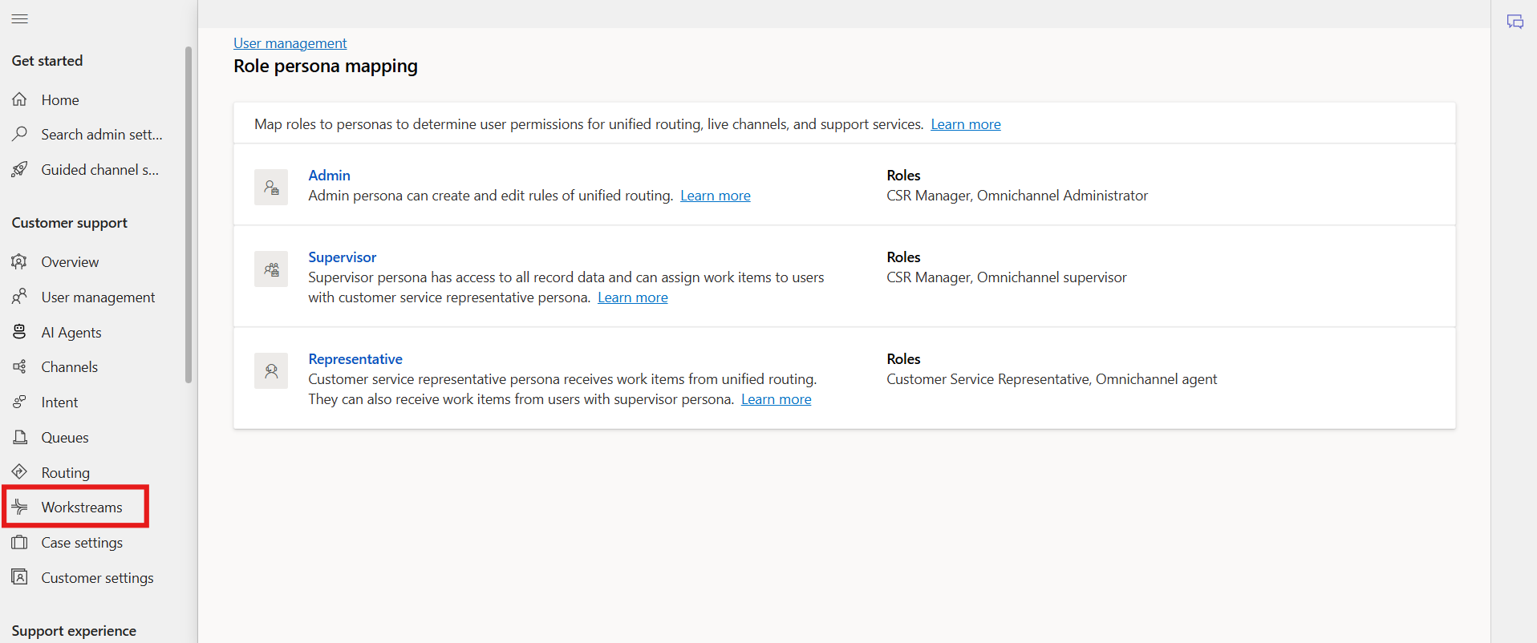
- Select + New workstream from top of the screen.
- 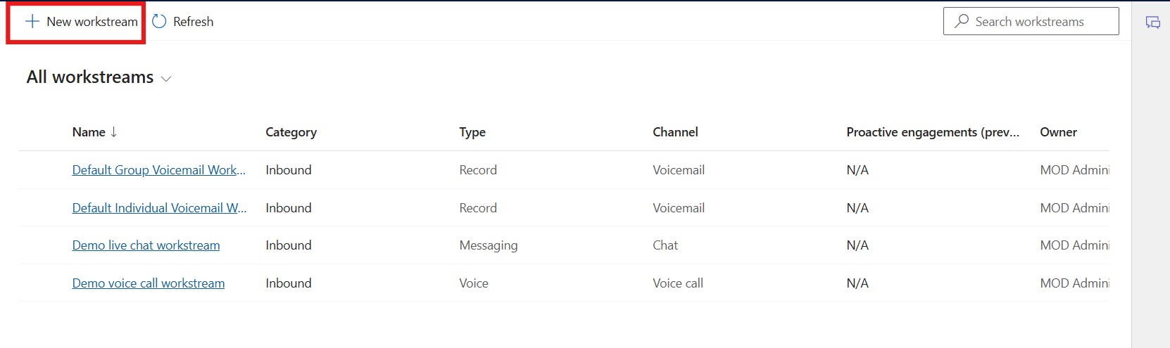
- On the Create a workstream dialoge, select Inbound and then select Next.
- 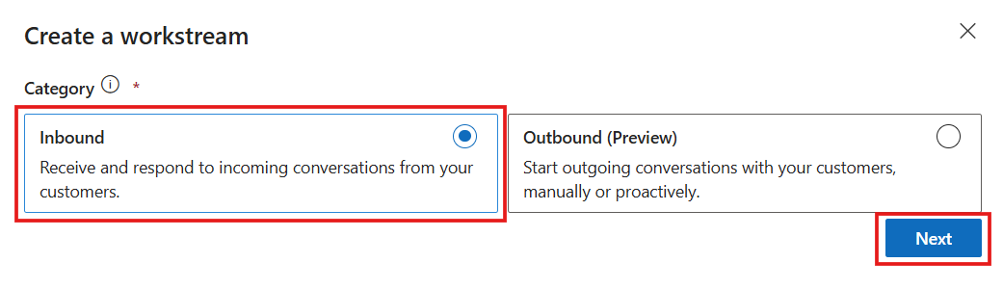
- Enter the following details:
  - Name: Enter an intuitive name - !!Contoso chat workstream!!
  - Type: Select Messaging
  - Channel: This box appears if you select the type as Messaging. Select Chat
  - Select Persistent Chat checkbox.
  - Work distribution mode: Select Push
  - In Fallback queue – Select Choose existing: Select Default messaging queue (All users)
  - Select Create.
- 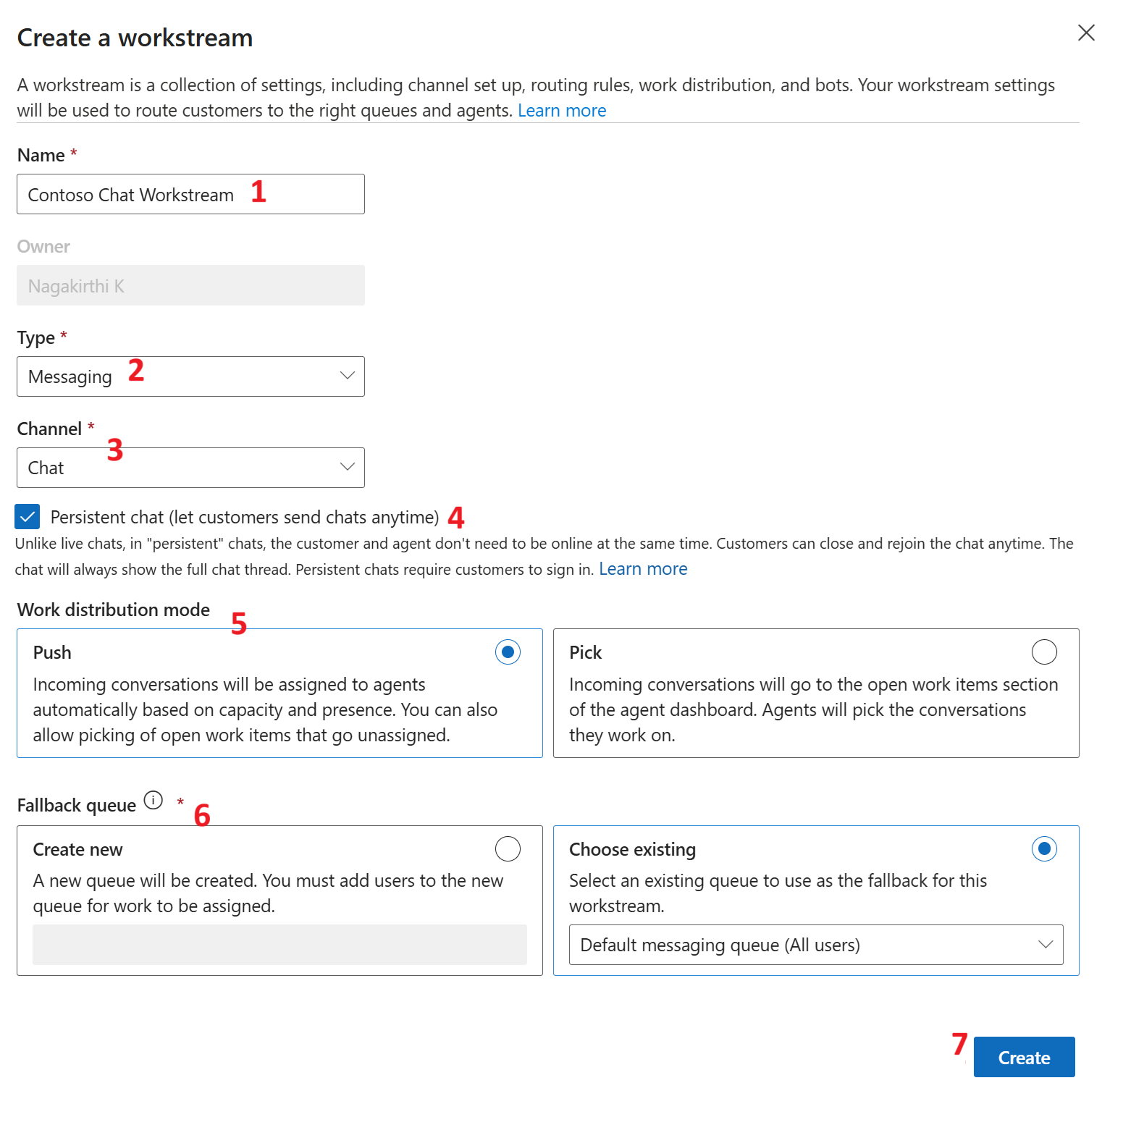
- The workstream that you created is displayed with the option to configure the selected channel instance.
- 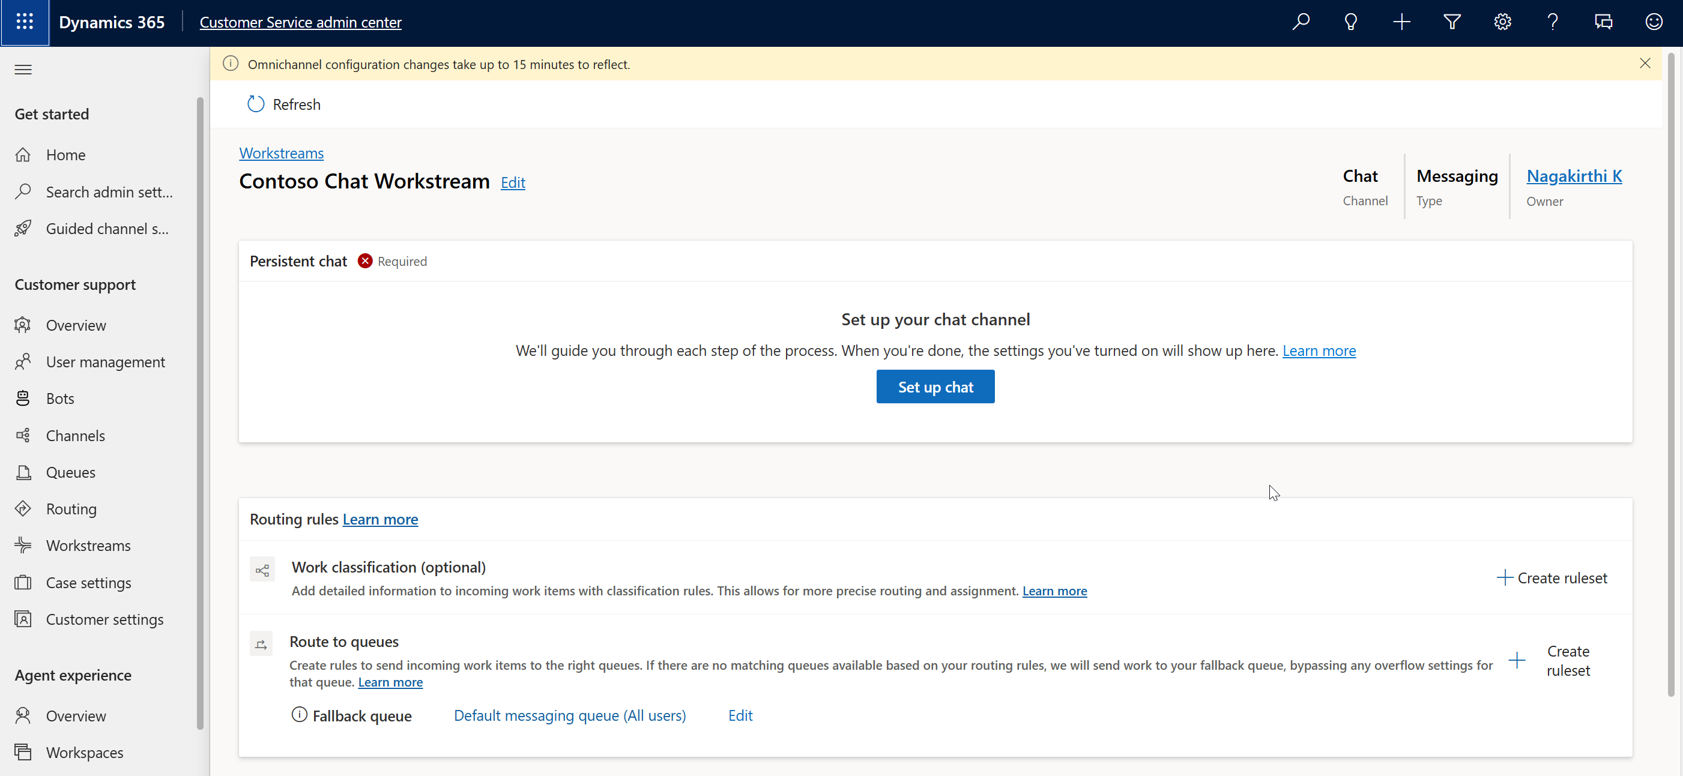

Task 2 - Edit, Copy, and Delete a Workstream
In this task, you will edit, copy, and delete workstreams. You will learn how to duplicate existing workstreams to reuse configurations and understand how to manage their lifecycle efficiently.
- Select Workstreams on the left navigation pane under Customer Support.
- Select Contoso chat workstream on the All workstreams page and select Edit on the command menu to edit the workstream.
- 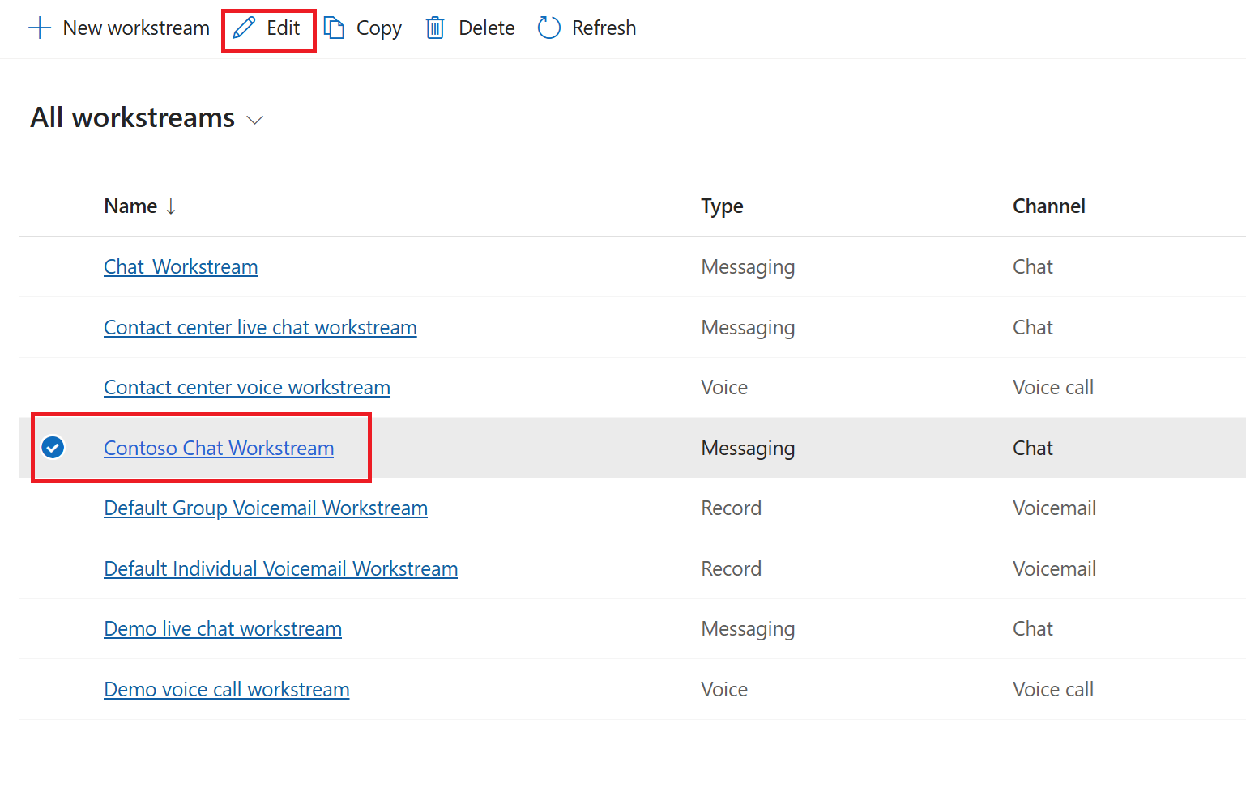
- To copy the Contoso chat workstream, select the workstream and click Copy on the command menu.
- 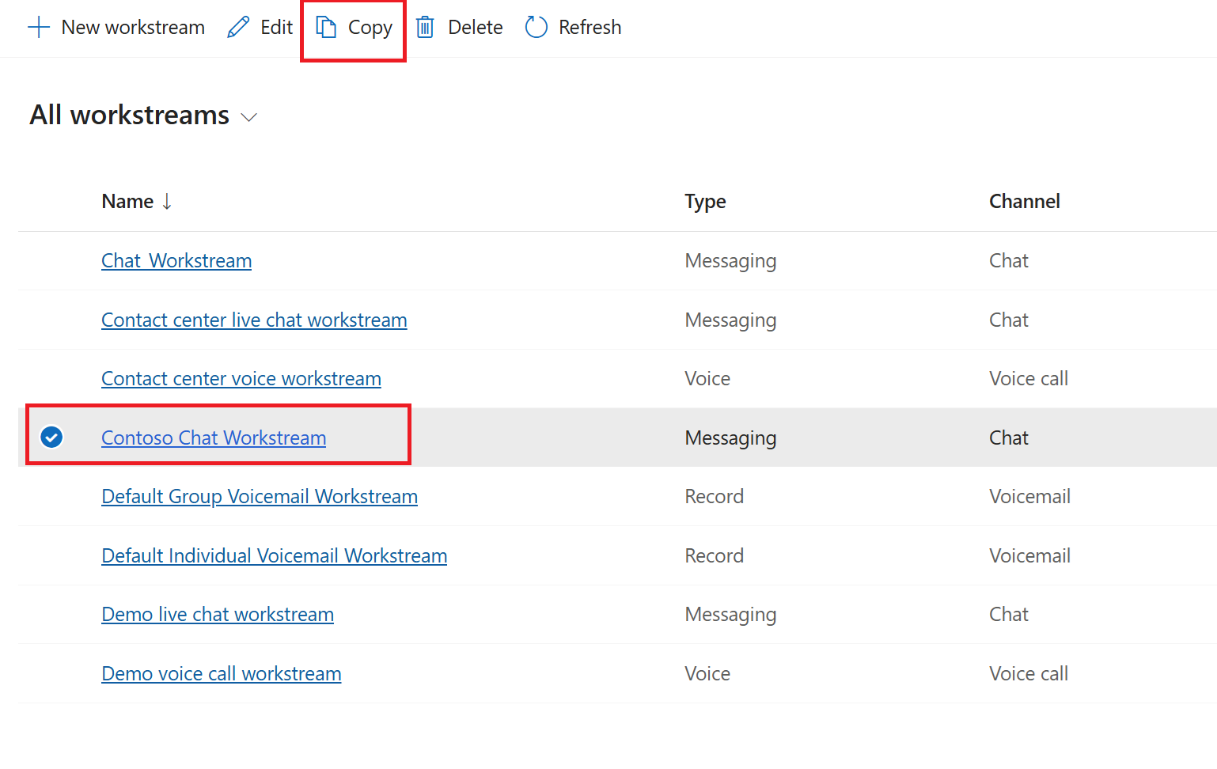
- Select Copy in the Do you want to copy this workstream? dialog.
- 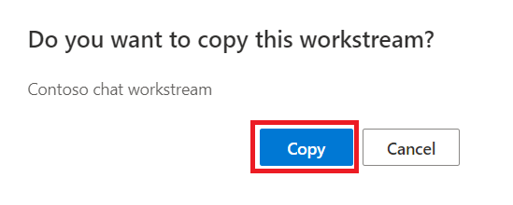
- The workstream is copied and inherits the settings of the workstream you copied from, including its name, prefixed with Copy of Contoso chat workstream.
- 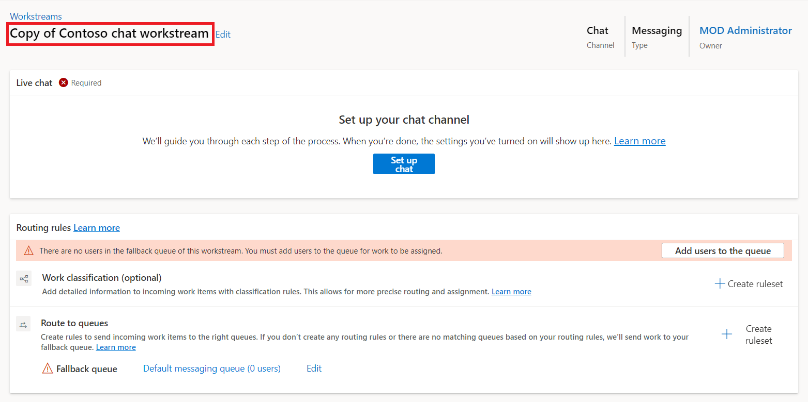
- To delete the workstream, select the workstream and click Delete.
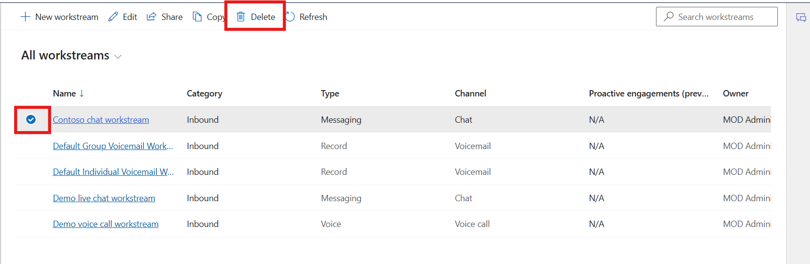

Exercise 2 - Create and Manage Queues

Task 1 - Create and Configure a New Queue
In this task, you will create a new queue named Contoso queue for supervisors, assign users, and configure queue priority and operating hours. You will also create a new operating hours record named Contoso operation hours and link it to the queue.
- In the site map of Copilot Service admin center, select Queues in Customer support.
- On the Queues page, select Manage for Advanced queues.
- 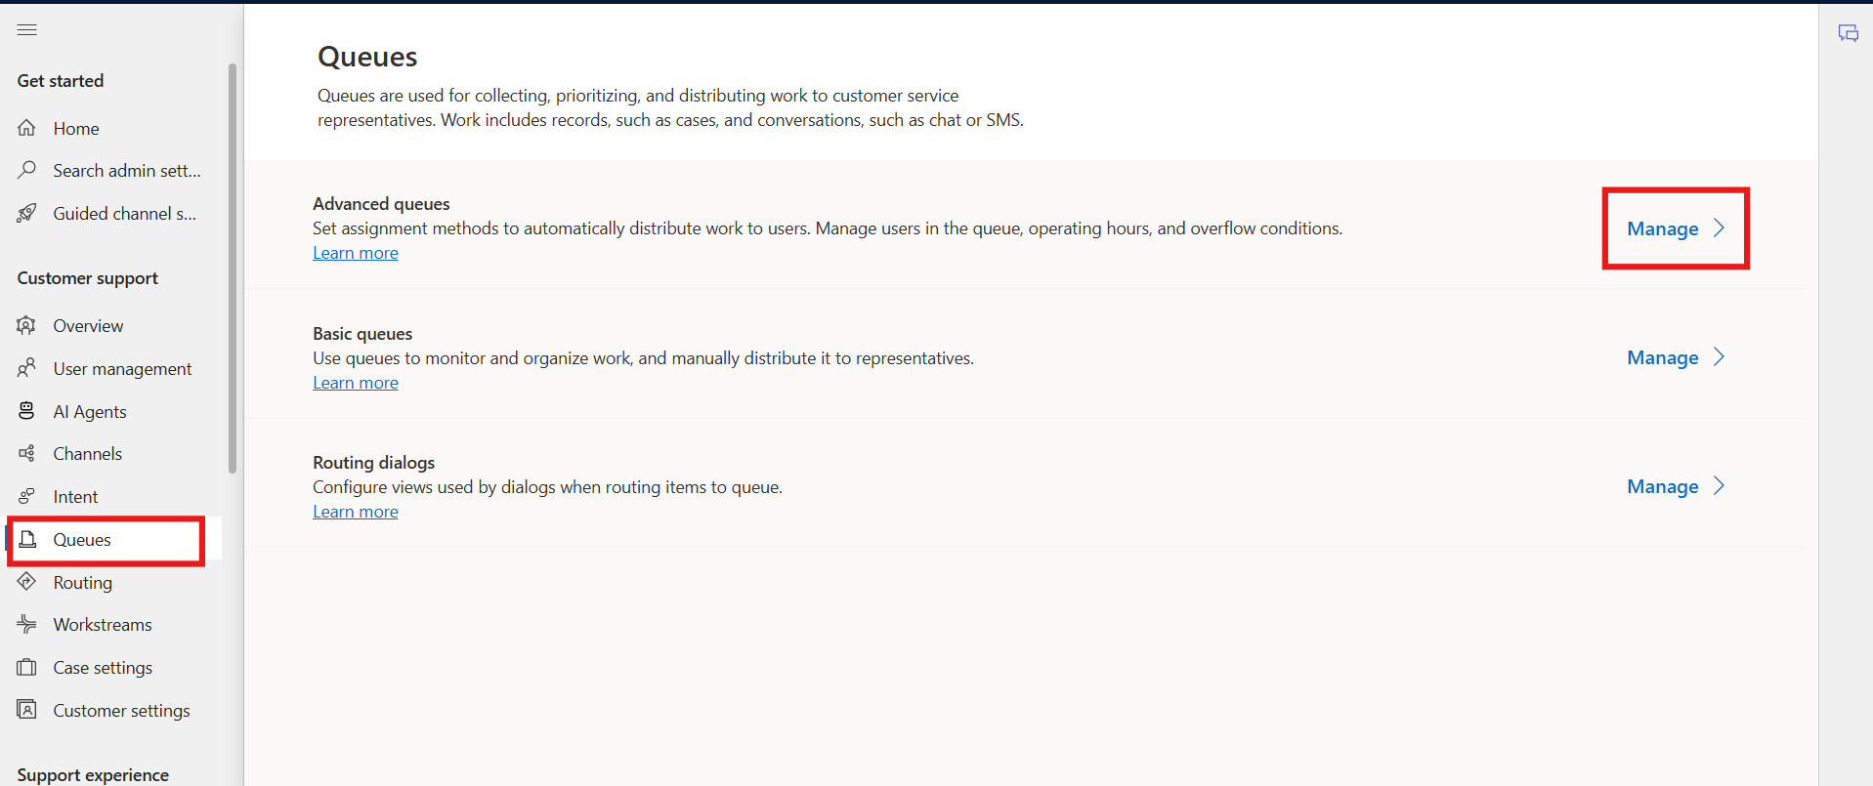
- On the Queues page, Select +New Queue
- 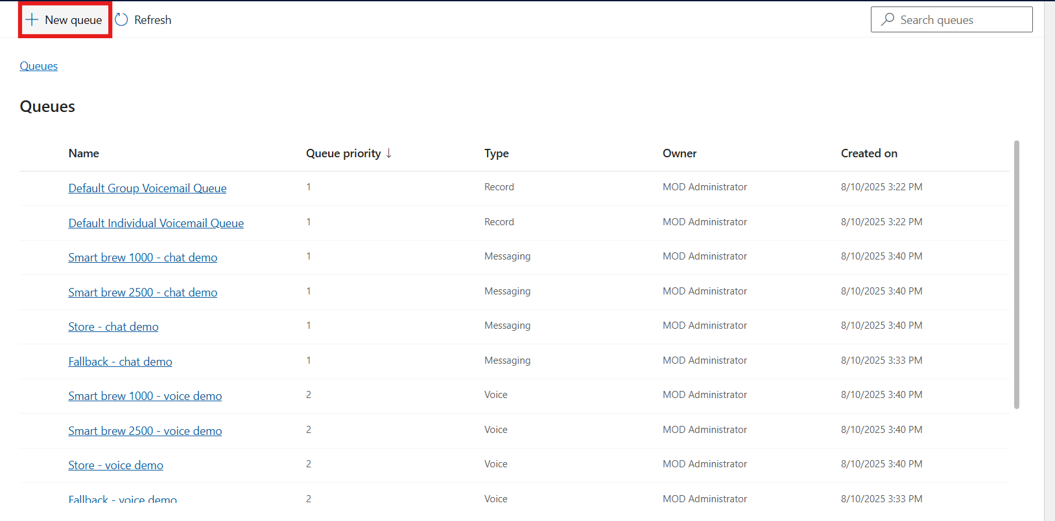
- In the Create a queue dialog, enter the following details:
  - Name: !!Contoso queue for supervisors!!
  - Type: Select Messaging
  - Queue Priority: !!1!!
  - Select Create
- 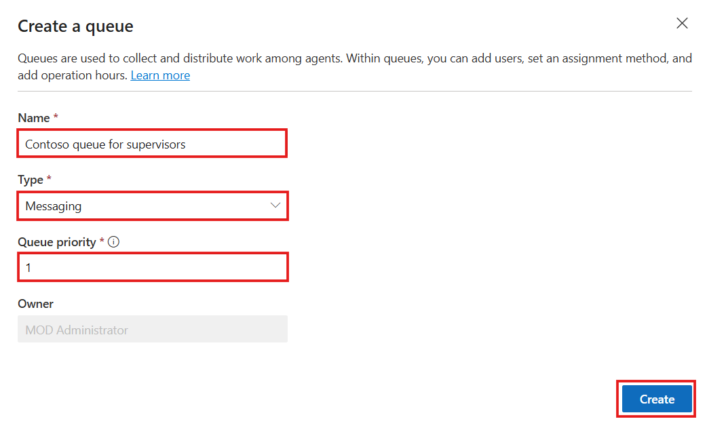
- The queue that you created is displayed.
- Select Add users, and in the flyout menu, select the MOD Administrator, and then select Add.
- 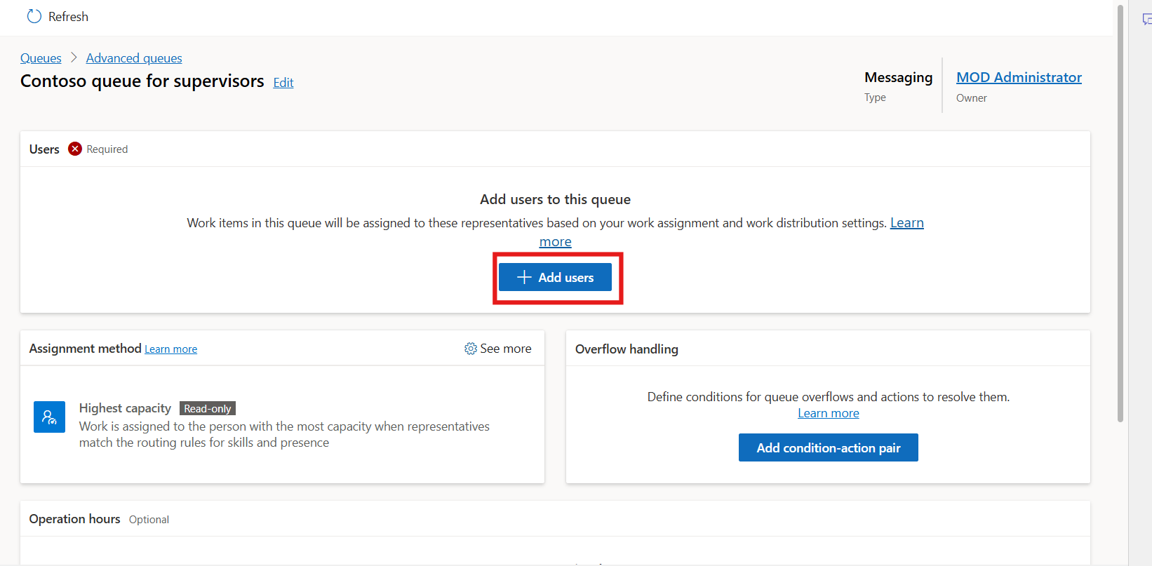
- 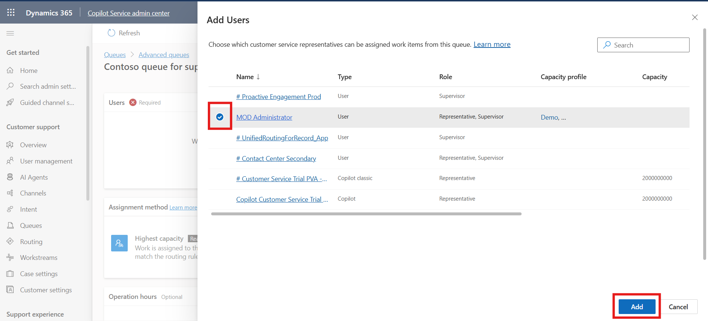
- The MOD Administrator is added to the queue.
- 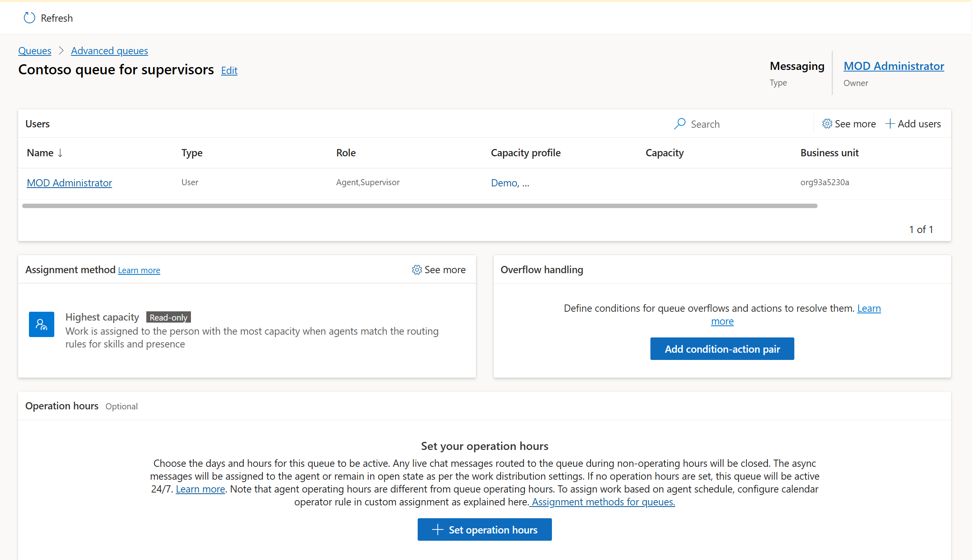
- In Assignment method, you can see Highest Capacity with Read-only.
- 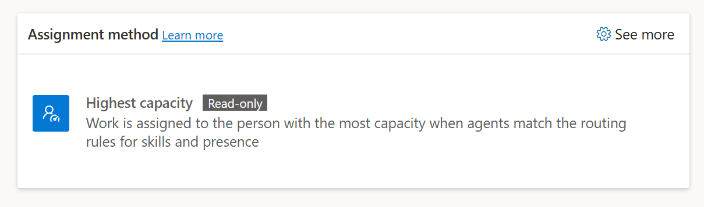
- To set the operating hours, in Operation hours, scroll down and select + Set operation hours.
- 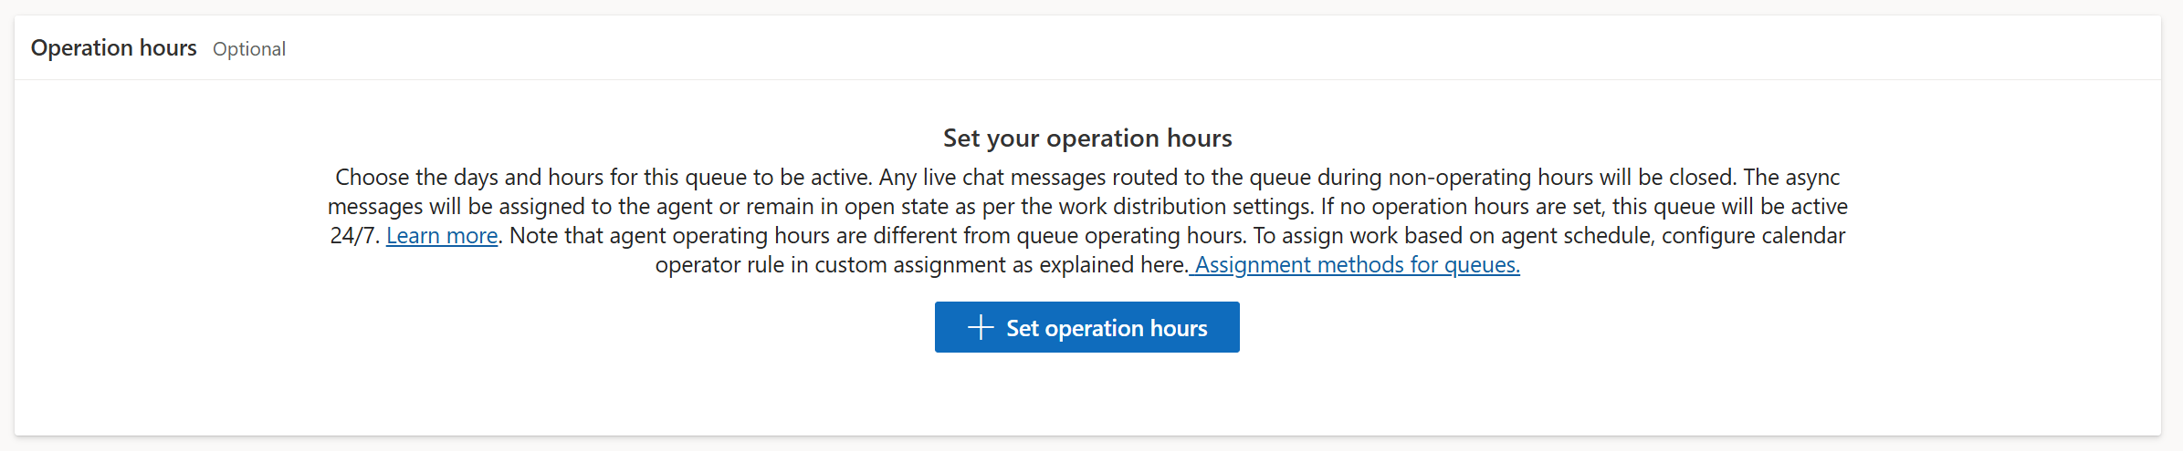
- On the Set operation hours dialog that appears, click the dropdown next to Select operation hours and then click + Create new.
- 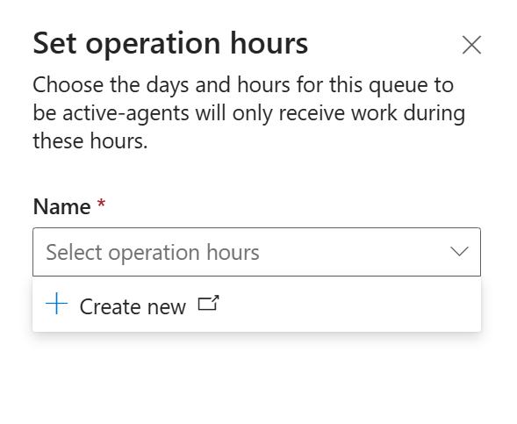
- On the New Operating Hour page, enter !!Contoso operation hours!! in the Name field and Description field.
- Click Save & Close to navigate back to the Contoso queue for supervisors page.
- 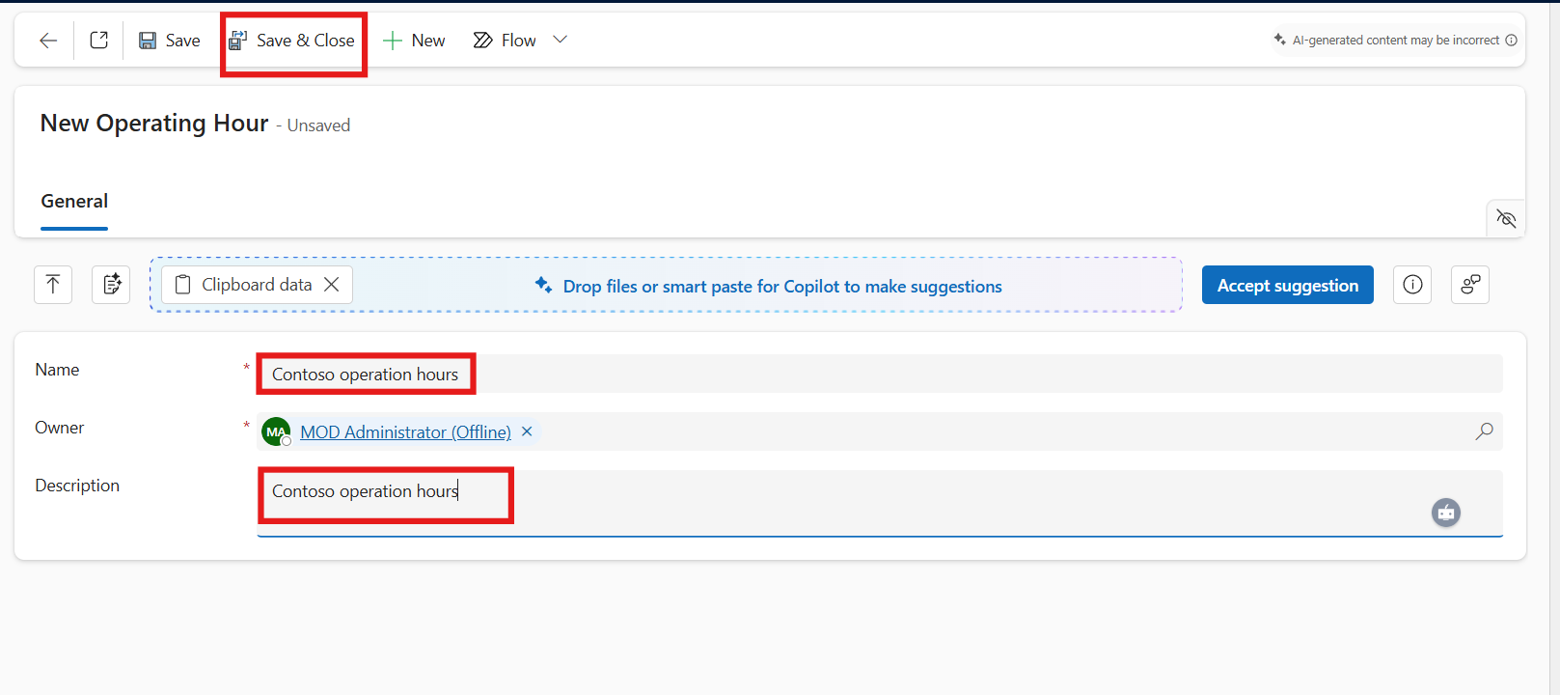
- Note: If popup windows appear, click on Continue anyways.
- 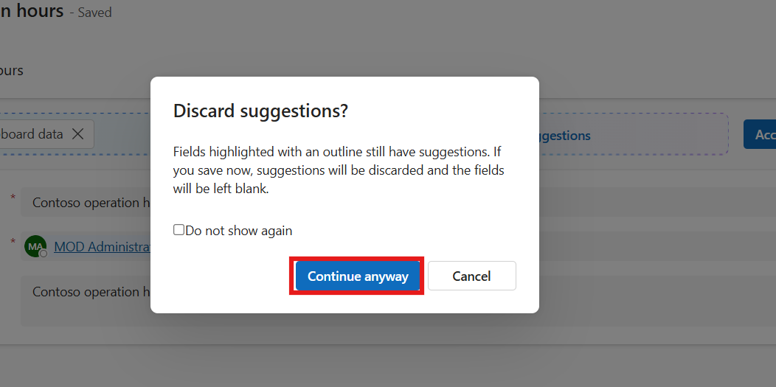
- On the Contoso queue for supervisors page, click + Set operation hours again.
- On the Set operation hours pane, search for and select Contoso operation hours and click Save and close.
- 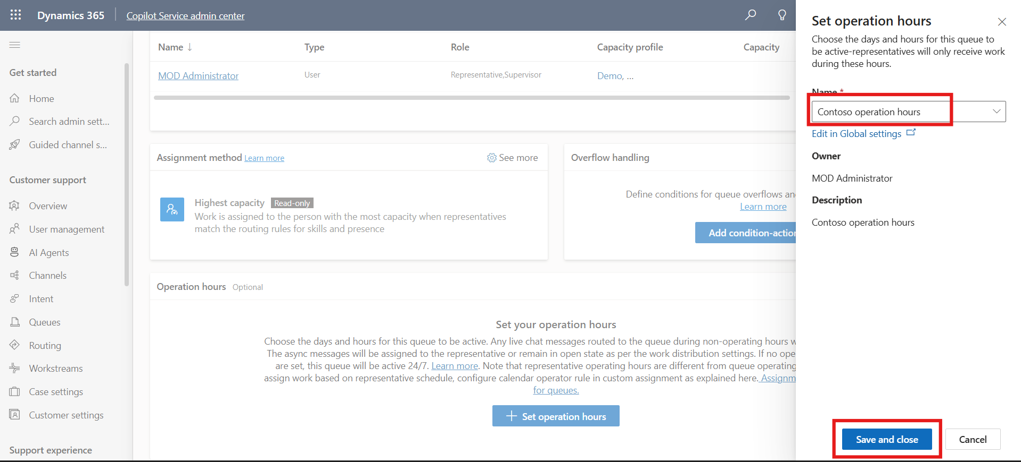
- The operation hours record that you selected is configured for the queue.
- 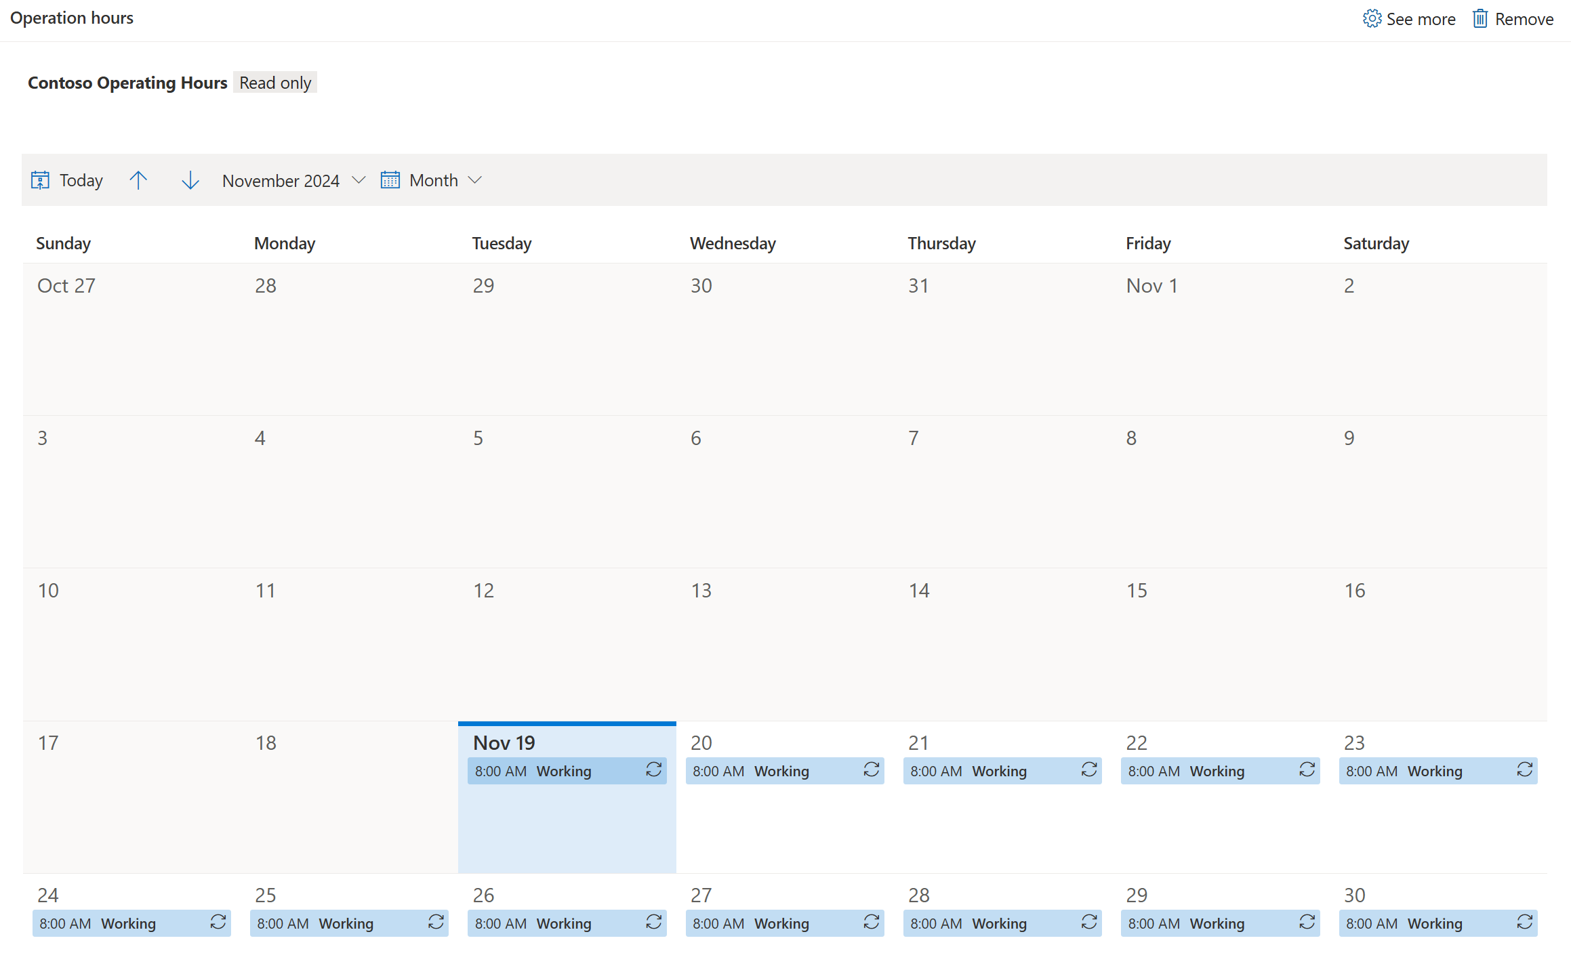

Task 2 - Copy an Existing Queue
In this task, you will copy the Contoso queue for supervisors to create a duplicate queue with inherited settings. This helps in quickly setting up similar queue configurations for different teams or departments.
- Navigate to queue, Select Advanced Queues Manage, select contoso queue for supervisors and then select Copy from top bar. Again, click on the Copy button.
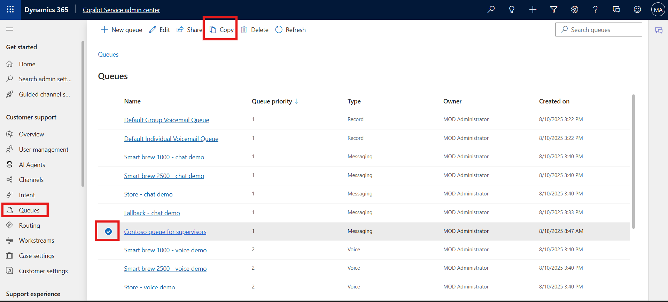
- 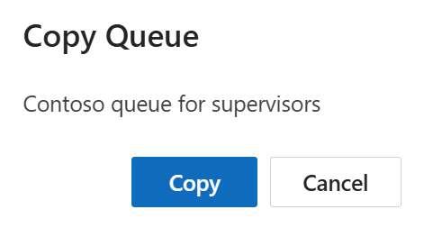
- The queue is copied and inherits the settings of the queue you copied from, including its name, prefixed with Copy of Contoso queue for supervisors.
- 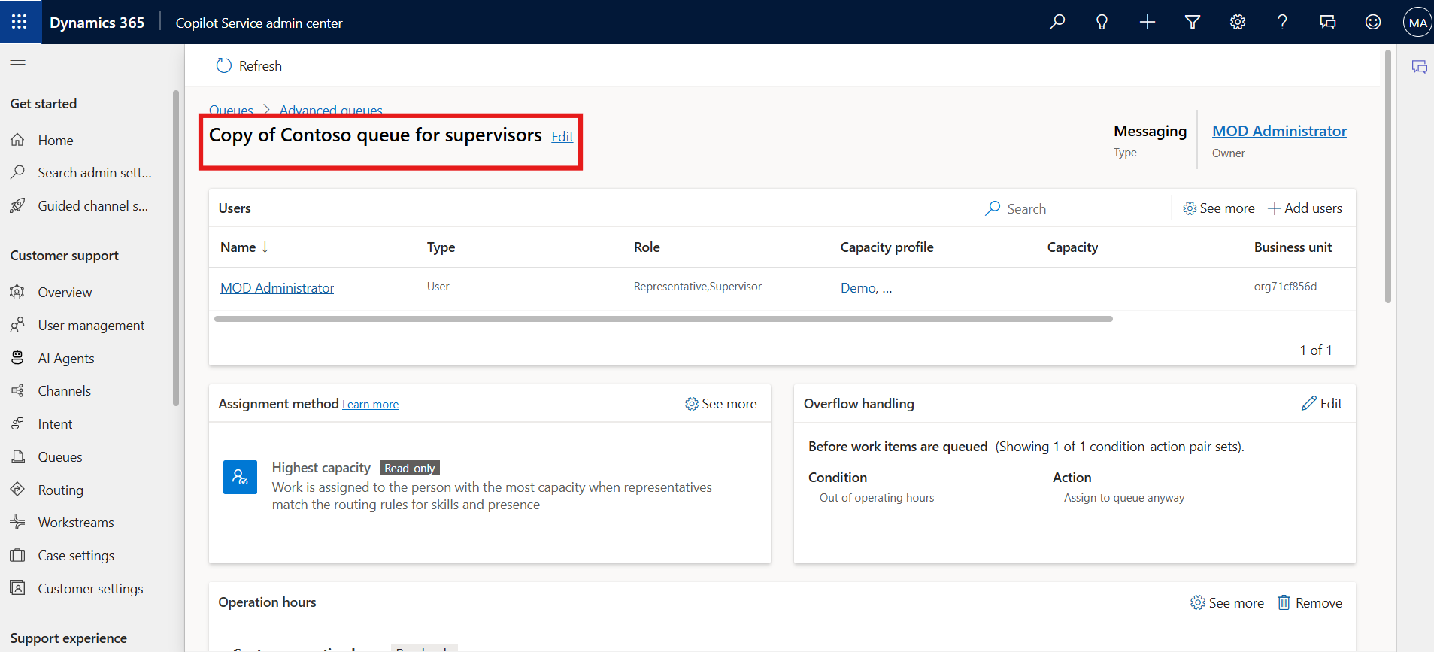

Conclusion:
By completing this lab, you have successfully created, configured, and managed workstreams and queues in the Copilot Service admin center. You learned how to define customer interaction channels, assign users, and set operational hours to ensure efficient and continuous support delivery within your contact center.

